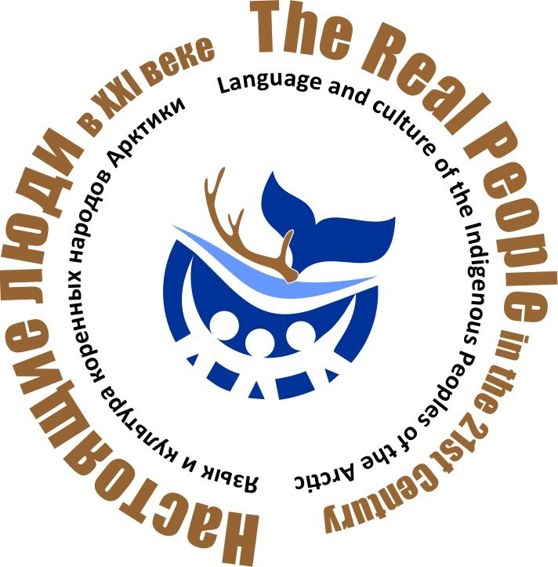
International Conference
"REAL PEOPLE in the XXI century:
LANGUAGE AND CULTURE OF THE INDIGENOUS PEOPLES OF THE ARCTIC»

The self-designation of many indigenous peoples of the Arctic literally translates to "real people". The word "real" is understood now as natural, close to nature, able to feel and understand their land, imbued with it and rooted in it with their roots. We propose to discuss how these people live today – in an age of rapid change, innovation, rapid development of technology and universalization.
In 2022, the conference is aimed at discussing issues of preserving the language, traditional culture and lifestyle of a few indigenous peoples living in the Arctic zone of the Russian Federation and in adjacent subarctic territories against the backdrop of changing social conditions.

Purposes of the conference:
- discussion of the problems and prospects of studying the linguistic and cultural diversity of the indigenous peoples of the Arctic;
- popularization and dissemination of positive experience in preserving the language and culture of indigenous minorities;
- presentation of publications, projects, dictionaries, collections, websites and other sources on the preservation of the language and culture of indigenous peoples;
- consolidation of efforts of scientists, authorities, institutions and public associations of indigenous peoples in the preservation of the language and culture of Arctic residents.

Dates: October 11 and 12, 2022

Conference location: Anadyr city, Chukotka Autonomous Okrug, Lenin St. 23, District House of Folk Art (HFA) and the Museum Center "Heritage of Chukotka".

Participants of the conference: anthropologists, linguists, ethnographers, folklorists, historians, Arctic researchers, representatives of state and public organizations, active indigenous people, keepers of traditions, experts of the native language, employees of educational institutions, museums, scientific institutes and centers.

Conference organizers:

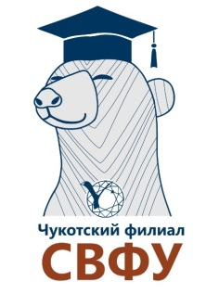
Chukotka Branch of Federal State Autonomous Educational Institution of Higher Education "M. K. Ammosov North-Eastern Federal University" (NEFU)

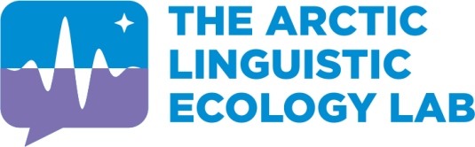
International Laboratory
«The Arctic linguistic ecology lab»
NEFU

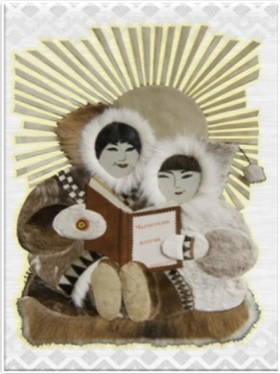
Regional public organization
"Native word – Chychetkin wetgav"

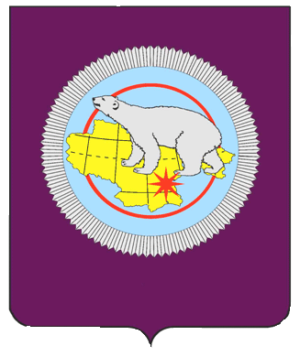
Department of Culture, Sports and Tourism of the Chukotka Autonomous Okrug

Conference Partners:

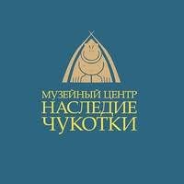
Museum Center "Heritage of Chukotka"

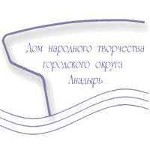

State Autonomous Cultural Institution of the Chukotka Autonomous Okrug "District House of Folk Art"

